CALCULATOR DEVELOPED USING HTML CSS AND JAVASCRIPT

**Abstract** : This work aims to design and develop a simple calculator web application using HTML, CSS, and JavaScript.

The Calculator performs basic arithmetic operations such as addition, subtraction, multiplication, and division.

The user-friendly Interface is created using HTML and CSS, while JavaScript handles the calculations and error handling.

The application is Designed to be responsive, accessible, and easy to use.

This project demonstrates the application of web development fundamentals To create a practical and useful tool, showcasing the potential of HTML, CSS, and JavaScript in building functional web Applications.

**Index Terms** – Calculator, HTML, CSS, JavaScript

1. **INTRODUCTION**

In today’s digital age, calculators have become an indispensable tool for individuals from various walks of life, from students to Professionals. The advent of web development technologies has enabled the creation of interactive and functional calculators that Can be accessed online[1]. This project aims to leverage the capabilities of JavaScript, CSS, and HTML to develop a simple Calculator that performs basic mathematical operations. The calculator’s significance extends beyond its mathematical Functionality, as it also serves as a testament to the power of web development in creating user-friendly and interactive tools. By Harnessing the potential of JavaScript, CSS, and HTML, developers can craft innovative solutions that cater to diverse needs and Requirements[2]. The development of a simple calculator using web development technologies offers a unique opportunity to Explore the intricacies of JavaScript, CSS, and HTML. This project allows developers to delve into the world of web development, Experimenting with various elements, styles, and functions to create a functional and visually appealing calculator. A simple Calculator makes everyday calculations effortless, saving time and mental calculation. A web-based calculator is accessible Anywhere, anytime, making it convenient for quick calculations. One can see the practical application of programming concepts in A tool they use daily, making learning more engaging and relevant. By creating a simple calculator, we demonstrate how Programming concepts can be applied to everyday life, making education more meaningful and impactful[3].

1. **DESIGN ASPECT OF THE MODEL**

The simple calculator developed using CSS, HTML, and JavaScript has the following features:

• Responsive Design: A basic layout with a display screen and a keypad that adapts to different screen sizes using CSS, ensuring Usability on various devices.

• Keypad: A comprehensive keypad with number buttons (0-9), basic operation buttons (+, -, x, /), clear (C) and equals (=) buttons, Allowing users to input numbers and operations easily

• Display Screen: A clear and concise display screen that shows input numbers and operations, and displays calculation results in Real-time, enabling users to track their calculations

• JavaScript Functionality: Robust JavaScript functionality that handles user input, validates numbers and operations, performs Calculations, and updates the display screen with results, ensuring accurate and efficient calculations[4].

• Basic Operations: Supports basic arithmetic operations, including addition (a + b), subtraction (a – b), multiplication (a x b), and division (a / b), catering to everyday calculation needs.

• Additional Features*: Includes a clear button to reset the calculator, an equals button to calculate and display results, and basic Error handling for invalid input, enhancing user experience.

• CSS Styles: Employs CSS styles to enhance visual appeal, with carefully selected colours, fonts, layout, positioning, and visual Effects for button hover and active states, making the calculator visually appealing and user-friendly[3].

1. **SOFTWARE EXPANSION FOR CREATING THE CALCULATOR** 
   1. Understand the basics of HTML, CSS, and JavaScript
   2. Apply web development fundamentals to create a practical web application
   3. Design and develop a user-friendly interface using HTML and CSS
   4. Implement basic arithmetic operations using JavaScript
   5. Develop robust error handling mechanisms
   6. Deploy web applications on a web server or hosting platform [5]
2. **METHODOLOGY FOR DEVELOPING THE CALCULATOR**

Step 1: Create the HTML Structure (calculator.html)

Step 2: Style the Calculator with CSS (calculator.css)*

Step 3: Add JavaScript Functionality (calculator.js)*

Step 4: Implement Calculator Logic

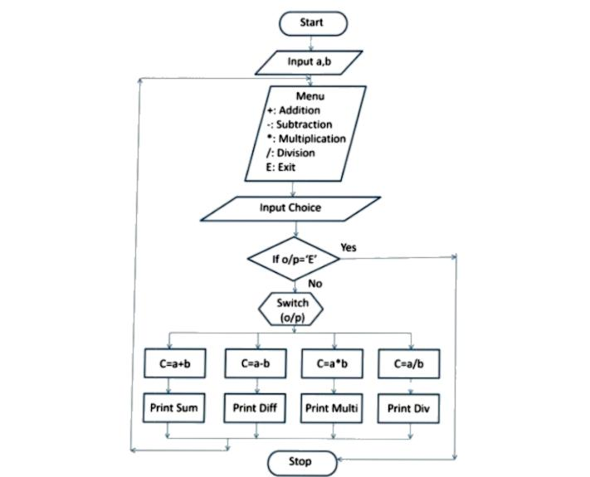 Figure 1. Flowchart of the developed model.

The calculator consists of the following components: Numbers (0-9), Addition (+),Subtraction (-), Multiplication (x), Division

(/),Equals Button (=),Clear Button (C),Display Screen.

The developed software model is shown below in figure2.

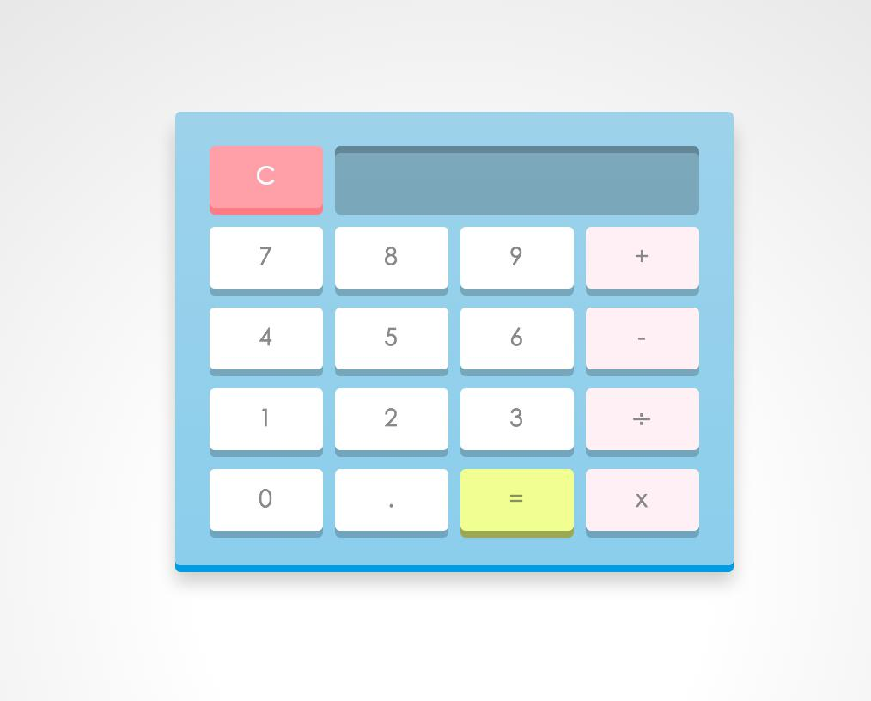

Figure2. Software model of the developed calculator

1. **RESULT AND ANALYSIS**

The mathematical components work together to enable the calculator to perform basic arithmetic operations and display the

Some sample examples of addition and division process with proper results are shown in

50+95

145

100/2

50

The developed calculator showing proper addition and division results.

1. **CONCLUSION**

In conclusion, the HTML code calculator is a simple yet effective tool for performing basic mathematical operations like addition,

Subtraction, multiplication, and division. By leveraging HTML, CSS, and JavaScript, this calculator provides an intuitive and userfriendly interface for users to input numbers and select operations. The JavaScript code handles the calculations and displays the Results, making it a great example of how web development technologies can be used to create functional and interactive web

Pages. HTML provides the structure and content for the calculator’s user interface. CSS styles and layouts the calculator’s design

And layout. JavaScript handles user input, performs calculations, and displays results. This work demonstrates the potential of web

Development technologies in creating useful and interactive tools for everyday use. With further development and enhancements,

This calculator could be expanded to include additional features and functions, making it an even more valuable resource for users

**REFERENCES**

[1] https:/ldeveloper. Mozilla.org/en-US/docsLearn/JavaScript/First_steps/What_is_JavaScript 2] <https://webflow.com> blog/how-to-design-a-website (3] https:/iwww.javatpoint.com’css-tutorial

[4] https:/iwww.tutorialspoint.com/ess/index.htm [5] https:iwww.geeksforgeeks.org/html-tutorial/